Test Case: tc006_SPX_Dev5_Crear_Requisicion_Spot_Tipo_Cobro_Proyect_Urgent
Step 1 - Enter username and password and click to button Enter: Credentials Entered
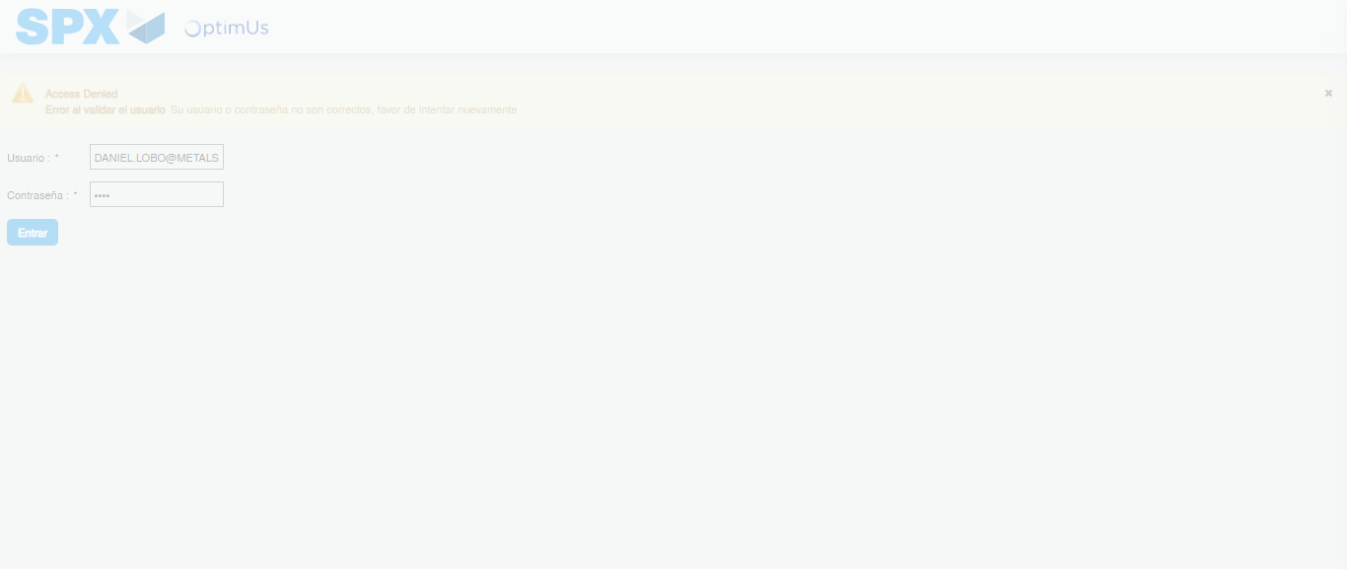Image file-name: QC_Testing-tc006_SPX_Dev5_Crear_Requisicion_Spot_Tipo_Cobro_Proyect_Urgent-1784215538429

Step 2 - Select to UEN and Access to Spot Buy Requisitions : UEN Correctly selected and Correct access
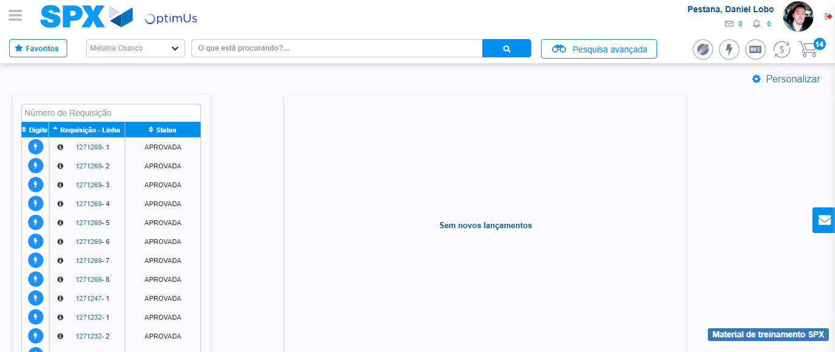Image file-name: QC_Testing-tc006_SPX_Dev5_Crear_Requisicion_Spot_Tipo_Cobro_Proyect_Urgent-1784215564178

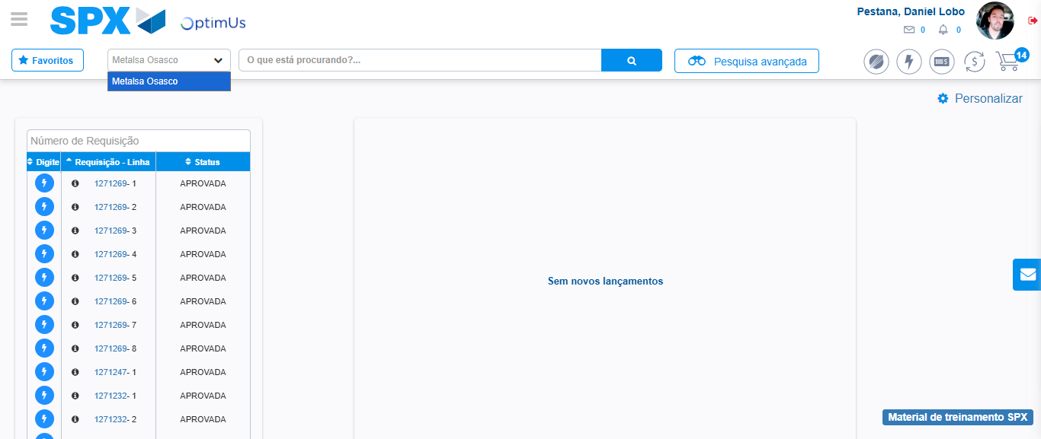Image file-name: QC_Testing-tc006_SPX_Dev5_Crear_Requisicion_Spot_Tipo_Cobro_Proyect_Urgent-1784215566770

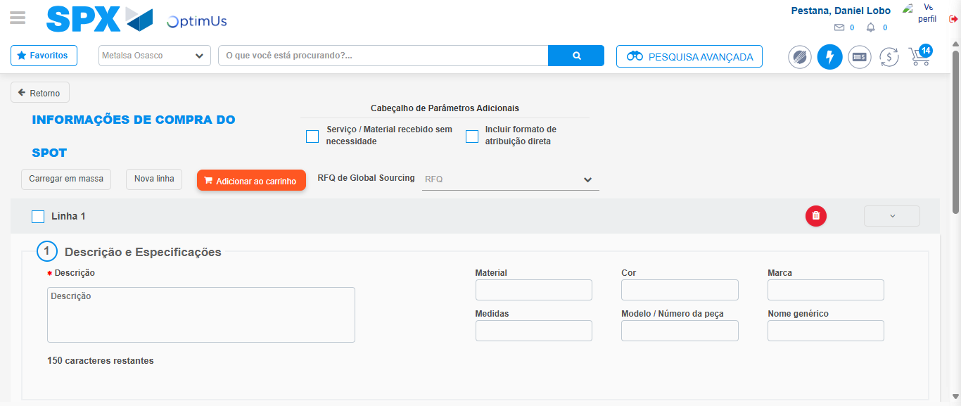Image file-name: QC_Testing-tc006_SPX_Dev5_Crear_Requisicion_Spot_Tipo_Cobro_Proyect_Urgent-1784215586470

Step 3 - Data Capture Spot Buy Requisition: Data captured correctly
Image file-name: QC_Testing-tc006_SPX_Dev5_Crear_Requisicion_Spot_Tipo_Cobro_Proyect_Urgent-1784215586715

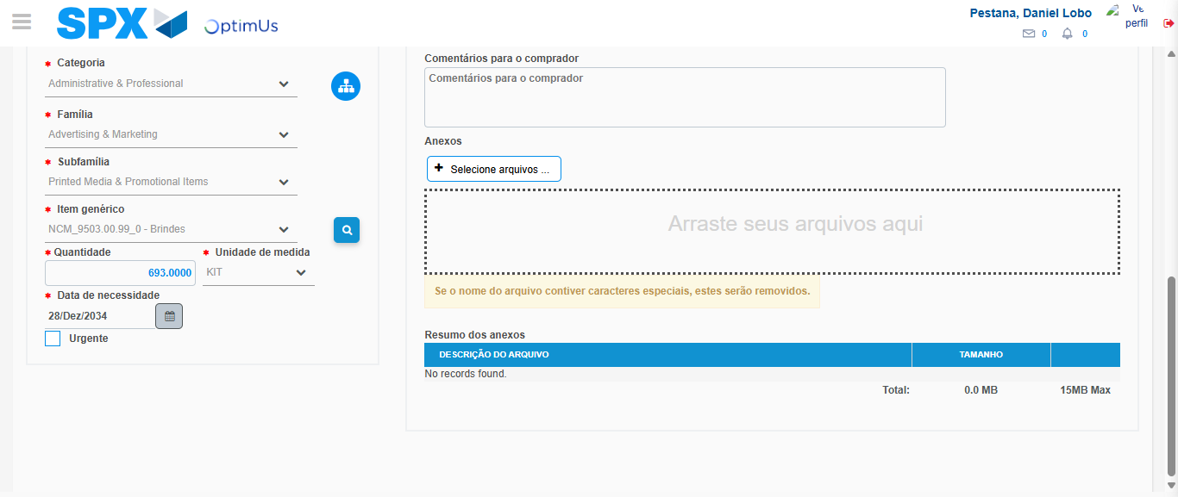Image file-name: QC_Testing-tc006_SPX_Dev5_Crear_Requisicion_Spot_Tipo_Cobro_Proyect_Urgent-1784215600428

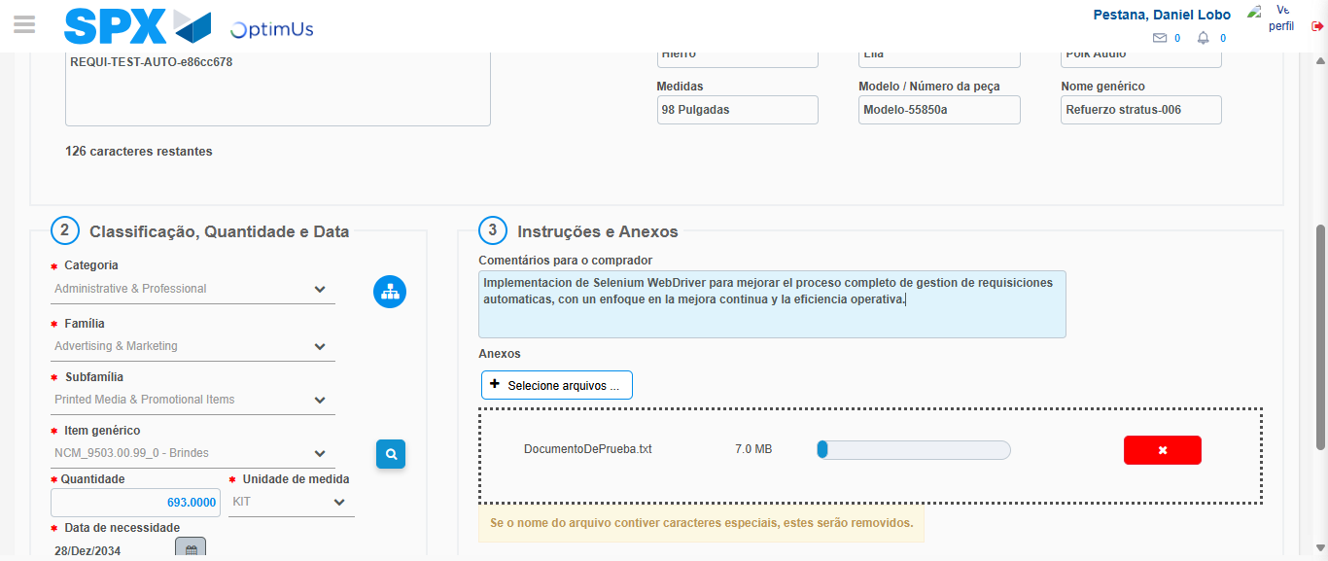Image file-name: QC_Testing-tc006_SPX_Dev5_Crear_Requisicion_Spot_Tipo_Cobro_Proyect_Urgent-1784215601411

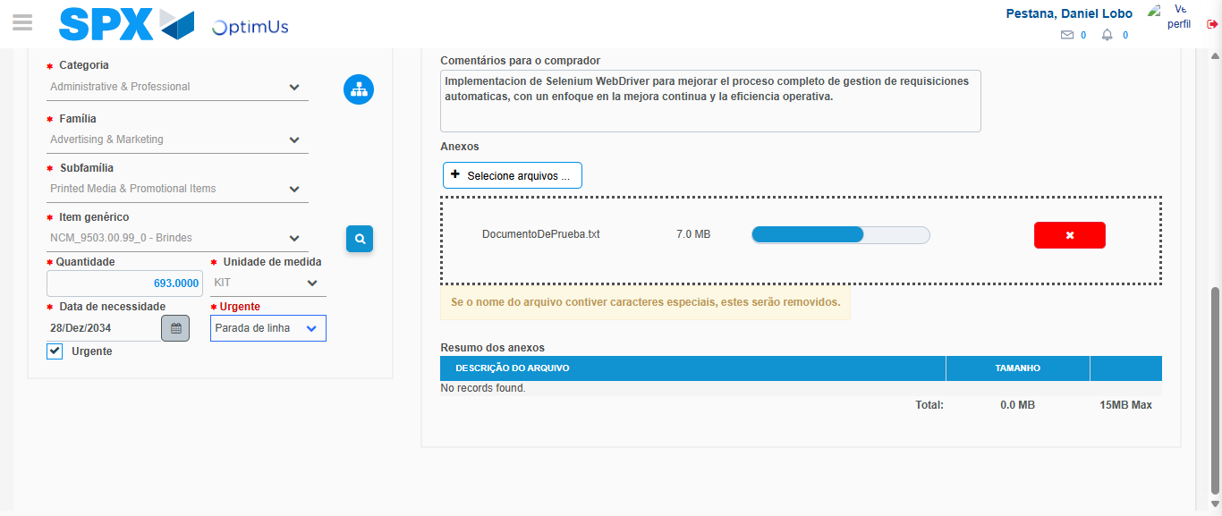Image file-name: QC_Testing-tc006_SPX_Dev5_Crear_Requisicion_Spot_Tipo_Cobro_Proyect_Urgent-1784215605349

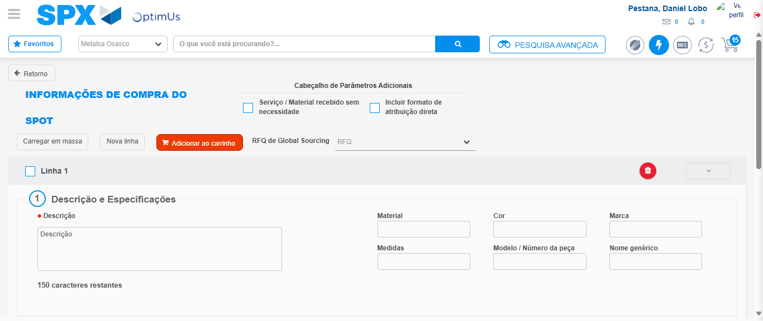Image file-name: QC_Testing-tc006_SPX_Dev5_Crear_Requisicion_Spot_Tipo_Cobro_Proyect_Urgent-1784215611576

Step 7 - Return to Main Page SPX : Return to Main Page SPX
Image file-name: QC_Testing-tc006_SPX_Dev5_Crear_Requisicion_Spot_Tipo_Cobro_Proyect_Urgent-1784215564178

Image file-name: QC_Testing-tc006_SPX_Dev5_Crear_Requisicion_Spot_Tipo_Cobro_Proyect_Urgent-1784215566770

Image file-name: QC_Testing-tc006_SPX_Dev5_Crear_Requisicion_Spot_Tipo_Cobro_Proyect_Urgent-1784215586470

Image file-name: QC_Testing-tc006_SPX_Dev5_Crear_Requisicion_Spot_Tipo_Cobro_Proyect_Urgent-1784215613831

Image file-name: QC_Testing-tc006_SPX_Dev5_Crear_Requisicion_Spot_Tipo_Cobro_Proyect_Urgent-1784215614020

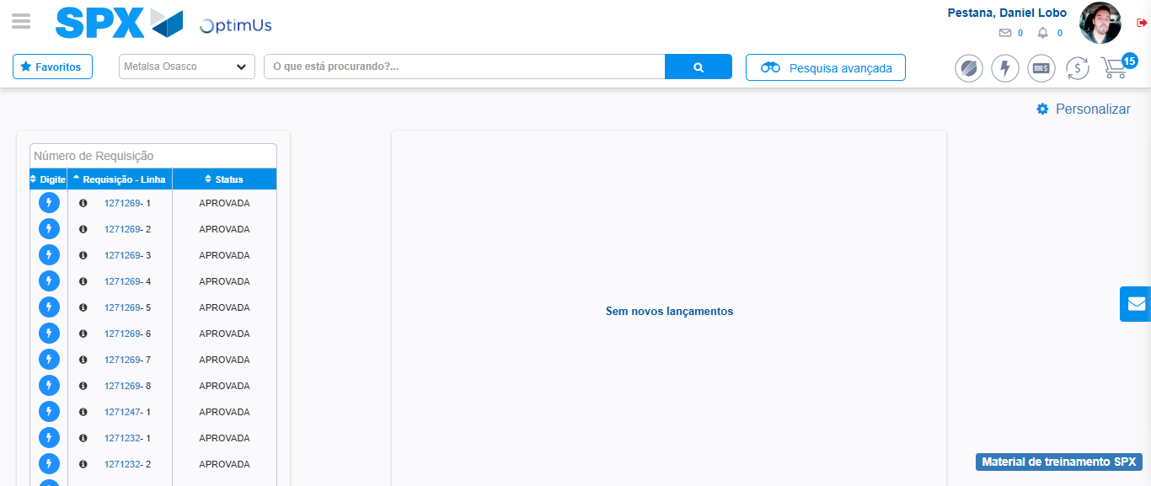Image file-name: QC_Testing-tc006_SPX_Dev5_Crear_Requisicion_Spot_Tipo_Cobro_Proyect_Urgent-1784215635162

Step 8 - Log Out : Log Out SPX
Image file-name: QC_Testing-tc006_SPX_Dev5_Crear_Requisicion_Spot_Tipo_Cobro_Proyect_Urgent-1784215635422

